Management Instruction for Tooling Dataset

1 Scope

This management instruction regulates the source, numbering method, revision management and releasing method of tooling dataset.

This management instruction is applicable to commercial aircraft production.

This management instruction is developed according to the requirements of GLC14070202.

2 Reference Documents

GLC14070202 Management Procedure for Design and Change of Tooling

GLC231007 Management requirement for Technical Document

GLC231008 Management Procedure for Quality Records

3 Forms

None

4 Terms and Definitions

None

5 Responsibilities

5.1 Source of the tooling dataset

The tooling dataset mainly come from customers, Self-design, Translation Design, Translation and Duplication, etc.
5.2 Numbering method of the tooling dataset

Each tooling with independent functions shall have a separate tooling drawing number. The efficiency tooling drawing number is the same, but it should be distinguished by a separate serial number. Only one single number is available for every set of tooling drawings, with no repeated use allowed. An obsolete drawing number shall no longer be used.
5.3 Numbering Method
□-ZH-□□□□-S□N

Shop's self-made tooling code (non-self-made tooling is not applicable to this item)
Code of designing and requesting department
English initial of SACC

Tooling Identifier (Assembly code in production)
Tooling Type Code
Prefix indicating tooling purposes
Tooling sequential number

Code of a setting-up fixture
Program Code
5.3.1
The codes of designing and requesting departments shall accord with Corporate Organizations Codes.
5.3.2
Tooling Identifier: referred to the engineering drawing number and semicolon. It can also be other drawing numbers and semicolons as specified. Redesign of the same tool shall not obsolete the original tooling, and the tooling identifier is to be suffixed with A, B,C……
5.3.3
Tooling Type Code: consisting of a group of letters indicating the function of this tooling or the type of work this tooling performs. It is usually the acronym of the English tooling nomenclature (refer to Appendix A).
5.3.4
Tooling Purpose Prefix: indicating the purpose of the tooling (Refer to Appendix B).
5.3.5
Tooling Sequential Number: When a series of tooling bear the same tooling type code, and are used in different operations of the same part, then the Tooling Sequential Number is supplied additionally to show the sequence of operations with 2, 3, 4……(Sequential No 1 is omitted). Example:

Tooling No. 1: FAJ5-50000-1

Tooling No. 2: 2FAJ5-50000-1

Tooling No. 3: 3FAJ5-50000-1
5.3.6
The maximum total number of digits in any tooling sequence number, tooling purpose prefix and tooling type code shall not exceed 6 characters.
5.3.7
Code of setting-up fixtures shall only be applicable to assembling the toolings by setting-up fixtures.
5.3.8
Program code shall be in accordance with the requirements in Appendix A of GLC231007, unless otherwise specified.
5.3.9
Refer to Appendix C for examples of tooling drawing numbering.
5.4 Title blocks of Tooling Drawings
5.4.1
The title block of the master drawing shall comply with the requirements of Appendix D, D1.
5.4.2
The title block of the assembly drawing shall comply with the requirements of Appendix D, D2.
5.4.3
The title block of the detail drawing shall comply with the requirements of Appendix D, D3.
5.4.4
The title block of the electric drawing shall comply with the requirements of Appendix D, D4.
5.4.5
It is necessary to discuss with Standardization department for modifying the format of the title block or increasing (or decreasing) the title block information.
5.5 Design requirements for tooling Dataset
5.5.1
Three dimensional mould design of tooling Dataset should comply with the regulations of temporary industry standards and enterprise standards.
5.5.2
The drafting requests, numbering principles and revision management of tooling technique documents should comply with the regulation in GLC231007.
5.6 Management requirements for tooling Dataset
5.6.1
Tooling drawing should comply with this procedure regulation.
5.6.2
Tooling Dataset code should comply with this procedure regulation.
5.6.3
The customers' requirements shall be respected if they have established special requirements for numbering of tools.
5.6.4
Discussion with standardization department is necessary if increase (or decrease) the group code.
5.7 Modification of tooling Dataset

Modification of tooling drawing should comply with the regulation in GLC14070202.
5.8
Specified requirements for tooling drawing of B777 and B787 program

Specified title blocks style reference appendix E, increasing engineering dataset and edition information, the rest are in accordance with appendix D.
5.9 Tooling dataset revision Management

Management Tooling dataset revision according to GLC14070202.
5.10 Tooling Data Release

Release Tooling Data according to GLC14070202.

6 Standard Legend Description

None

7 Record control

7.1
Fill and maintenance relevant records according to the requirements of procedure GLC231008.

附录A Appendix A
(规范性附录) Normative Appendix
工装类别代码表Tooling Type Code
工装类别代码表见表A.1 Tooling Type Code refer to Appendix A
表A.1 工装类别代码表 Tooling Type Code
工装类别代码  Tooling Type Code | 类 别 名 称  Tooling Type Name | 类 别 名 称  Tooling Type Name
ACT | AUTOMATION CONTROL TOOL | 自动控制工装
AFDF | ABRASIVE FLOW DEBURR FIXTURE | 抛光夹具
AJ | ASSEMBLY JIG | 装配型架
AM | ASSEMBLY MODEL | 装配模型
AOGT | AIRPLANE-ON-GROUND TOOL | 飞机地面工装
ATT | APPLY TRIM TEMPLATE | 修整样板
BALU | BONDING ASSEMBLY LAYUP | 胶接支承模具
BARF | BONDING ADHESIVE RETICULATING FIXTURE | 粘合剂网状夹具
BATE | BASE ACTIVATION TEST EQUIPMENT | 基座启动试验设备
BCFJ | BONDING CORE FORM JIG | 粘合芯成形模
BD | BLANKING DIE | 落料模
BDGF | BONDING DEGREASE FIXTURE | 粘合除油夹具
BF | BROACHING FIXTURE | 拉削夹具
BFD | BLANK & FORM DIE | 落料成形模
BFLT | BRAKE FORM LOCATING TEMPLATE | 弯曲成形定位样板
BGM | BONDING GLYCONOL MOLD | 粘合GLYCONOL模型
BITE | BASE INTALLATION TEST EQUIPMENT | 地面安装试验设备
BMOF | BONDING MELT OUT FIXTURE | 粘合熔化夹具
BOF | BORING FIXTURE | 镗孔夹具
BPFD | BLANK、PIERCE & FORM DIE | 落料、冲孔和成形模
BPHB | BAG PRESS HYDRO BLOCK | 橡皮囊压形模
BPPF | BOND PIN PERFORATION FIXTURE | 粘合冲孔夹具
BT | BLANKING TOOL | 下料工装
BTF | BONDING TREPAN FIXTURE | 粘合钻孔夹具
CB | CORE BOX | 芯盒

表A.1（续Continuation）
工装类别代码  Tooling Type Code | 类 别 名 称  Tooling Type Name | 类 别 名 称  Tooling Type Name
CD | COMPUTER DATA | 计算机数据
CDM | CERAMIC DIE MODEL | 陶瓷模型(CDM)
CF | CHECKING FIXTURE | 检查夹具
CFD | CUTOFF & FORM DIE | 切断成形模
CFF | CREEP FORM FIXTURE | 蠕变成形夹具
CGT | COMPUTER GENERATED TEMPLATE | 计算机制造的样板
CKT | CLOTH KIT TEMPLATE | 布工具袋样板
CL | CENTERLINE/CUTTERLINE DATA | 中心线/刀具线数据
CLKT | CLOTH LAYOUT KIT TEMPLATE | 布设计工装袋样板
CLT | CORE LOCATING TEMPLATE | 芯定位样板
CMT | CHEM-MILL TEMPLATE | 化铣样板
CMTB | CHEMICAL MILL TEMPLATE BASE | 化铣样板基座（基准）
CND | COINING DIE | 压印模
COD | CUTOFF DIE | 切断模
CP | CAUL PLATE | 抛光模
CPC | CAPSULE PLATING CAPSULE | 囊式镀囊
CPD | CUTOFF & PIERCE DIE | 切断冲孔模
CPFD | CUTOFF、PIERCE & FORM DIE | 切断、冲孔和成形模
CPS | CAPSULE PLATING SHIELD | 囊镀罩
CSPFD | CERAMIC SUPERPLASTIC FORM DIE | 陶瓷超塑成形模具
CST | CROSS SCETION TEMPLATE | 切面样板
CT | CONTOUR TEMPLATE | 外形样板
CTT | CORE TRIM TEMPLATE | 型芯修整样板
DBJ | DIP BRAZING JIG | 浸焊夹具
DBT | DEVELOPED BLANK TEMPLATE | 展开下料样板
DCT | DIE CONSTRUCTION TEMPLATE | 模具制造样板
DF | DRILL FIXTURE | 钻模夹具
DFT | DESIGNED FACILITY TOOL | 有图设备工装
DJ | DRILL JIG | 钻模
DLT | DEVELOPED LAYOUT TEMPLATE | 展开划线样板
DM | DRAW/BENDING MANDREL OR BLOCK | 拉伸/弯曲心棒成模
DRD | DRAW DIE | 拉伸模
DSNT | DRIVMATIC SONIC NORMATION TEMPLATE | 动态声测标准化样板
DT | DRILL TOOL | 钻孔工装
DYBA | DYNAMIC BALANCING ARBOR | 动力平衡杆
ECF | ENVELOPE CHECK FIXTURE | 包线检查夹具
EFM | ELECTROFORM MANDREL | 电成形心棒
EMT | EXTERIOR MARKING TEMPLATE | 外部标记样板
FACT | FLEXIBLE ASSEMBLY CELL TOOL | 柔性装配工具
FAJ | FLOOR MOUNTED ASSEMBLY JIG | 固定在地面上的装配型架
FB | FORM BLOCK | 型胎(模胎、检验模等)
FBAR | FAIRING BAR | 罩杆
FBT | FORM BLOCK TEMPLATE | 型胎样板
FCSF | FLUID CUTTING SAW FIXTURE | 液体切削锯夹具
FCT | FORM CUTTING TOOL | 成型切削工装
FD | FORM DIE | 成形模
FG | FACILITY GAGE | 简易量规
FHFD | FURNACE HEATED FORM DIE | 热成形模
FMD | FOAM MOLD DIE | 泡沫改装模
FME | FLOOR MOUNTED EQUIPMENT | 地面安装设备
FPBJ | FIBER PLACEMENT BONDING JIG | 纤维粘接型架
FPM | FIBER PLACEMENT MANDREL | 纤维心棒
FR | FORMING ROLL | 成形滚
FT | FIXTURE TEMPLATE | 夹具样板
G | SPECIAL GEARLINE GAGES | 专用齿线量规
GF | GRINDING FIXTURE | 研磨夹具
GGF | GEAR GRINDING FIXTURE | 齿轮研磨夹具
GHF | GEAR HOBBING FIXTURE | 滚齿夹具
GSF | GEAR SHAVING FIXTURE | 插齿夹具
GSHF | GEAR SHAPING FIXTURE | 剃齿夹具
GSS | GAGE SUPPORT STAND | 量规支架
GTD | GAGE TREE DRAWING | 量规树形图
GTF | GEAR TESTING FIXTURE | 齿轮测试夹具
HB | HYDROPRESS BLOCK | 液压模胎
HBFD | HYDRAULIC BULGE FORM DIE | 液压胀形成形模
HCCD | HONEYCOMB CRUSH DIE | 蜂窝挤压模具
HCFD | HONEYCOMB FORM DIE | 蜂窝成形模具
HCSF | HONEYCOMB STABILIZATION FIXTURE | 蜂窝稳定夹具
HCT | HOLE CHECKING TEMPLATE | 孔检查样板
HD | HAMMER DIE | 落锤模
HDAL | HAMMER DIE-ALUMINUM | 落锤模-铝
HDIC | HAMMER DIE-INCONEL | 落锤模-铬镍铁合金
HDP | HAMMER DIE PUNCH | 落锤模上模
HDSS | HAMMER DIE-STAINLESS STEEL | 落锤模-不锈钢
HDTT | HAMMER DIE-TITANIUM | 落锤模-钛合金
HEED | HIGH ENERGY ELECTRO HYDRAULIC DIE | 高能电液压模
HF | HOLDING FIXTURE | 固定夹具
HFCF | HAND FORM CHECK FIXTURE | 手工成形检查夹具
HFD | HYDRO FORM DIE | 液压成形模
HLT | HOLE LOCATING TEMPLATE | 孔定位样板
HMM | HOLLOW MOLD MANDREL | 空模心棒
HPHB | HIGH PRESSURE HYDRO BLOCK | 高压液压模胎
HRF | HAND ROUTER FIXTURE | 手工铣切夹具
HRFB | HAND ROUTER FIXTURE BASE | 手工铣切夹具基座
HSF | HOT SIZE FIXTURE | 热校形夹具
HTF | HEAT TREAT FIXTURE | 热处理夹具
ICF | INTERFACE CHECK FIXTURE | 接口检验夹具
IG | INSPECTION GAGE | 检验量规
IHFD | INTEGRALLY HEATED FORM DIE | 整体热成形模
IT | INTERIM TOOL | 临时工装
JD | JOGGLE DIE | 下陷模
JDT | JIG DRILL TEMPLATE | 型架钻孔样板
KFDP | KIRKSITE FORM DIE PUNCH | 锌合金成形模上模
KHD | KIRKSITE HAMMER DIE | 锌合金落锤模
KHDP | KIRKSITE HAMMER DIE PUNCH | 锌合金锻模上模
LF | LATHE FIXTURE | 车床夹具
LHF | LASER HOLDING FIXTURE | 激光夹具
LJ | LOCATING JIG | 定位型架
LM | LAYUP MANDREL | 叠层心棒
MA | MACHINE EQUIPMENT  MASTER TOOLS AND GAGES | 机床设备  标准工装和量规
MC | MILL CUTTER | 铣刀
MCD | MASTER CONTROL DRAWING | 标准控制图
MCG | MASTER CONTROL GAGE | 标准控制量规
MCW | MILL CUTTER-WICHITA | 铣刀-Wichita
MD | MOLD DIE | 铸造模型
MDG | MASTER DRILL GAGE | 标准钻孔量规
MDT | MARKING DOT TEMPLATE | 标记点样板
ME | MECHANICAL EQUITPMENT | 机械设备
MED | MANUFACTURING ENHANCED DATASET | 制造增强数据集
MF | MILL FIXTURE | 铣切夹具
MG | MASTER GAGE | 标准量规
MST | MISCELLANEOUS SPECIAL TOOLING | 其他专用工装
MT | MISCELLANEOUS TOOL | 其他工装
MJD | MASS JOGGLE DIE | 下陷模
MM | MASTER MODEL | 标准型模
MOLD | MOLD | 铸模
MST | MACON STANDARD TOOL | Macon标准工装
MT | MODULAR TOOL | 模块工具
MTC | MODULAR TOOL COMPONENT | 模块工具部件
MTT | MASTER TOOLING TEMPLATE | 标准工具样板
NCLT | NUMERICAL CONTROL LATHE TOOL | 数据车床工装
NCM | NUMERICAL CONTROL MEDIA | 数据媒体
NCHF | NUMERICAL CONTROL HOLDING FIXTURE | 数据模块夹具
NCMFT | NUMERICAL CONTROL MODUDAR FIXTURE | 数控组合夹具
NCMIT | NUMERICAL CONTROL MISCELLANEOUS TOOL (SAME AS NMIT) | 数控其他工装
NCIT | NUMERICAL CONTROL MISCELLANEOUS TOOL (SAME AS NCMIT) | 数控其他工装
OCT | OPTICAL COMPARATOR TEMPLATE | 光学比较样板
OHME | OVERHEAD EQUIPMENT | 高架设备
OPMCD | OFFICE PROGRAMMED MACHING DATA | 办公室编辑的机器控制数据
OT | OPTICAL TOOLING | 光学工装
PA | PRODUCTION AID | 生产辅助工装
PAD | PROGRAMMABLE AUTOMATION DATA | 可编程自动化数据
P | PATTERN | 模型
PATT | PLASTIC APPLY TRIM TEMPLATE | 塑料应用修整样板
PBD | PIERCE BLANK DIE | 冲孔落料模
PD | PIERCE DIE | 冲孔模
PFD | PIERCE & FORM DIE | 冲孔成形模
PF | PREFORM FIXTURE | 预成形夹具
PFT | PROFILE TEMPLATE | 铣切样板
PGFD | PROGRESSIVE & FORM DIE | 级进模
PHF | POLISHING HOLDING FIXTURE | 抛光固定夹具
PHFD | PRESS HEATE FORM DIE | 热压成形模
PI | PRODUCTION ILLUSTRATION | 生产图纸（说明）
PIM | PLASTIC INJECTION MOLD | 橡胶压模
PK | PACKAGING | 包装
PLF | PROOF LOAD FIXTURE | 安全载荷夹具
PLT | PLY LOCATING TEMPLATE | 层板固定样板
PM | PART MODEL | 零件模型
PME | PORTABLE MECHANICAL EQUIPMENT | 便携式机械设备
PMKT | PIN MANDREL KIT TEMPLATE | 心棒工具样板
PML | PRESSURE MANDREL | 压力棒
PMLF | PIN MANDREL LOCATING FIXTURE | 心棒定位夹具
PMLT | PIN MANDREL LOCATING TEMPLATE | 心棒定位样板
PPM | PLASTIC PRESS MOLD | 塑料注射模
PPST | PROPRIETARY PROGRAM STANDARD TOOL | 优先程序控制工装
PRE | PROTECTIVE EQUIPMENT | 保护设备
PS | PROCESS SHEET | 工艺单
PTFT | PRODUCTION TEMPORARY FACILITY TOOL | 生产临时简易工装
QBT | QUICR-CHANGE BLANHING TOOL | 快卸式下料工装
RAJ | RIVET & ASSEMBLY JIG | 铆接装配型架
RB | ROUTER BOARD | 铣切板
RBAJ | RETORT BRAZING ASSEMBLY JIG | 焊接装配型架
RBF | RETOTR BRAZING FIXTURE | 焊接夹具
RCF | ROLLER COAT FIXTURE | 辊涂夹具
RDT | ROUTER DRILL TEMPLATE | 铣切钻模
REPT | REFERENCE PHOTO TEMPLATE | 标准照相样板
RET | RETORT | 焊箱
RF | ROUTER FIXTURE | 铣切夹具
RIGT | RIGGING TOOL | 固定工装
RIT | RIVETING TOOL | 铆接工装
RJ | RIVETING JIG | 铆接型架
RLT | REFERENCE LAYOUT TEMPLATE | 标准划线样板
RM | ROTATIONAL MOLD | 旋转模
RPM | RUBBER PRESS MOLD | 塑料压模
RWJ | RESISTANCE WELD JIG | 电阻焊型架
SB | SPINNING BLOCK | 旋压模
SD | SHAVING DIE | 修剪模
SDFD | STRETCH DRAW FORM DIE | 拉伸成形模
SDG | SECONDARY DRILL GAGE | 二级钻规
SDT | SPEEDY DRILL TEMPLATE | 快速钻孔样板
SEG | SECONDARY GAGE | 二级量规
SF | SAW FIXTURE | 锯切夹具
SHF | SHAPER FIXTURE | 刨床夹具
SLD | SLOTTING DIE | 开槽模
SMCD | SHOP GREATED MACHING CONTROL DATA | 车间编制的机械控制数据
SME | SHIPPING MECHANICAL EQUIPMENT | 运输机械设备
SO | STANDING ORDER | 代用订单
SP | SAMPLE PART  SPECIAL TEST EQUIPMENT  SPECIAL TOOLING | 样件  专用试验设备  专用工装
SPF | SHOT PEEING FIXTURE | 喷丸夹具
SPFD | SUPERPLASTIC FORM DIE | 超塑成形模
SPT | SAMPLE PART TEMPLATE | 样件样板
SPVT | SHOT PEEN VERIPICATION TOOL | 喷丸校验工装
SST | STOCK SIZE TEMPLATE | 毛料尺寸样板
ST | STANDARD TOOL | 标准工具
STE | SPECIAL TEST EQUIPMENT | 专用试验设备
STF | STRAIGHTENING FIXTURE | 校直夹具
STFB | STRETCH FORM BLOCK | 拉形模（拉弯模）
STO | STANDING TOOL ORDER | 代用工装订单
SUT | SETUP TEMPLATE | 安装样板
SVT | SURFACE VERIFICATION TOOL | 表面检查工装
SWD | SWAGING DIE | 陷形模
TA | TOOLING AID | 辅助工装
TB | TEST BENCH | 试验台
TCT | THERMAL CUTTING TEMPLATE | 热切削样板
TD | TRIMMING DIE | 修整模
TE | TEST EQUIPMENT | 试验设备
THE | TEST EQUIPMENT HOOKUP | 试验设备联机
TFD | T CODED FORM DIE | T码成形模
TFT | TEMPORARY FACILITY TOOL | 临时简易工装
TGMD | TEXT & GRAPHICS-MED GEHERATED | MED编制的文本与图形
TGNC | TEXT & GRAPHICS-NC PROGGRAMMING GENERATED | 数控编程编制的文本与图形
TGPP | TEXT & GRAPHICS-PROCESS PLANNING GENERATED | 工艺设计编制的文本与图形
TGQC | TEXT & GRAPHICS-QC GENERATED | QC编制的文本与图形
TGSH | TEXT & GRAPHICS-SHOP GENERATED | 车间编制的文本与图形
TH | TEST HARNESS | 试验电缆
THF | THREADING FIXTURE | 螺纹加工夹具
TJ | TRIM JIG | 修整型架
TJD | T CODED JOGGLE DIE | T码下陷模
TME | TRANSPORTATION MECHANICAL EQUIPMENT | 运输机械设备
TMLO | TOOLING MASTER LAYOUT | 工装标准图
TS | TOOL SPECIFICATION | 工装规范
TSB | TOOL SUB BASE | 工装子基
TSF | TEST SUPPORT FIXTURE | 试验支持夹具
TSJ | TEST JIG | 试验夹具
TST | T CODED STANDARD TOOL | T 码标准工装
TTPF | TUBE TEE PULLOUT FIXTURE | 导管T形拔出夹具
UT | UTILITY TOOL | 应用工装
VCFF | VACUUM CREEP FORM FIXTURE | 真空蠕变成形模具
VFM | VACUUM FORMING MOLD | 真空成形模
VST | VELICOPTERS STANDARD TOOL | 直升机厂标准工具
VTSB | VACUUM TOOL SUB BASE | 真空工装子基
WAFB | WATER FORM BLOCK | 水压成形模
WFB | WIRE FORM BOARD | 划线板
WFF | WIRE FORM FIXTURE | 划线成形夹具
WJ | WELD JIG | 焊接（夹具）型架
WSC | WICHITA STANDARD CUTTER | Wichita标准刀具
WST | WICHITA STANDARD TOOL | Wichita标准工装
WUT | WICHITA UTILITY TOOL | Wichita应用工装
ZBAJ | INTERIOR PANEL BONDING ASSEMBLY JIG | 内部板粘结装配型架
ZDT | INTERIOR PANEL DRILL TEMPLATE | 内部板钻孔样板
ZFPBT | INTERIOR FOAM IN PLACE BOND TOOL | 内部泡沫定位粘合工具
ZLTT | INTERIOR PANEL LAYOUT & TRIM TEMPLATE | 内板布置修剪样板
ZHCHF | INTERIOR NUMERICAL CONTROL HOLDING FIXTURE | 内部数控固定夹具
ZNCRF | NUMERICAL CONTROL DESIGNED ROUTER FIXTURE | 内部数控用的铣切夹具
ZTF | INTERIOR PANEL TRIM FIXTURE | 内部板修整夹具
ZWRF | INTERIOR PANEL HOLDING FIXTURE | 内部板固定夹具

附录B Appendix B
(规范性附录) Normative Appendix
工装用途首码表Prefix indicating tooling purposes
工装用途首码表见表B.1 Prefix indicating tooling purposes refer to Appendix B
表B.1 工装用途首码表Prefix indicating tooling purposes
代号 | 用 途
B | 用于粘接装备的工装Tooling for bonding equipment
E | 研制工装Engineering development tooling
F | 车间装配工装Workshop assembly tooling
K | 部分或全部由Kirksite制造的工装Tooling partially or completely manufactured by Kirksite
LO | 供应商或保障部门在零件设计中使用的概念性工装Conceptual tooling used by supplier or support department in part design
NC | 用于数控生产的或由数控设备生产的作为定义和控制零件构型原始依据的工装（不考虑加工方法）。NC字首的使用由制造工程部门决定Tooling used for numerical control production or produced by numerical control equipment as the original basis for defining and controlling part configuration(regardless of processing method). NC is determined by Manufacturing Engineering
N | 当工装标识码和首码超过规定的6个字符时，用字符代替When the number of digits exceeds 6, replace it with the character N
P | 消耗工装Consume tooling
(S) | 缩比工装Scaling tooling
SA | 仅在Wichita使用，标识车间辅助性工装，SA首码应先出现，放在序号和工装码之前（如SA2DJ）。It is only used in Wichita to identify workshop auxiliary tooling. SA should appear between the serial number and tooling code
SY | 定期验证载荷实验（仅用于Wichita ME吊挂）Periodic proof load test(for Wichita ME hanging only)
WP | 工装制造使用的木模型Wooden model for tooling manufacturing
X | 实验性工装Experimental tooling
Y | 在波音主厂与承包商或分厂之间周转使用的工装Tooling used for turnover between Boeing main plant and contractor or branch plant
Z | 内修整板粘接过程中使用的工装Tooling used in the bonding process of inner trim panel

附录C Appendix C
(资料性附录) Informative Appendix
工装图样编号示例Examples of tooling drawing numbering

C.1 专用工装图样编号示例Examples of tooling drawing numbering

C.1.1 由35厂提出，工装设计室设计的德国AHD公司研制专用工装，工装识别号为5-50000-1的钻模，其编号为：
The special tooling developed by German AHD company, which is proposed by 35 factory and designed by the tooling design office, is the drill jig with tooling identification number 5-50000-1, and its number is:
S4-EDJ5-50000-1-S9100
C.1.2 由35厂提出，工装设计室设计的DASH8-400项目研制专用工装，工装识别号为4-40000-1的组合夹具钻模，其编号为：
The special tooling developed by DASH8-400, which is proposed by 35 factory and designed by the tooling design office, is the drill jig with tooling identification number 4-40000-1, and its number is:
S2A-ZH-EDJ4-40000-1-S9100

C.2 自制工装图样编号示例Example of self-made tooling drawing number

由35厂自制的德国AHD公司的研制工装，工装识别号为5-50000-1的钻模，其编号为：
The special tooling developed by German AHD company, which is designed by 35 factory, is the drill jig with tooling identification number 5-50000-1, and its number is:
S4-EDJ5-50000-1-S9100N

附录D Appendix D
(规范性附录) Normative Appendix
工艺装备图样标题栏The title block of the tooling

D.1 总图图样标题栏The title block of the master drawing

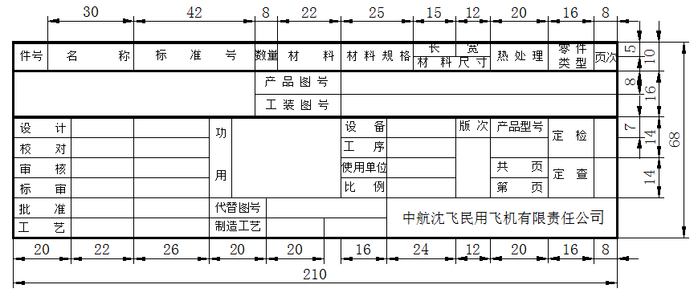

D.2 组合件图图样通用标题栏The title block of the an assembly drawing

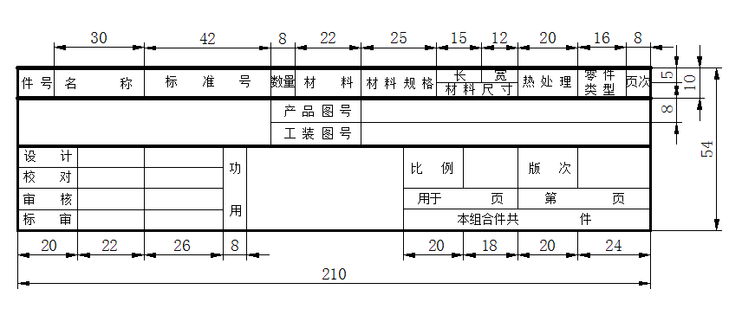

D.3 零件图图样通用标题栏The title block of the a detail drawing

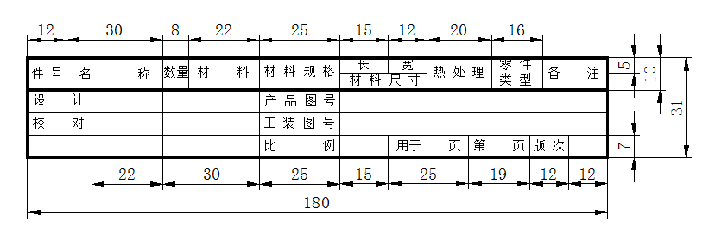

D.4 电器图图样通用标题栏The title block of the a electric drawing
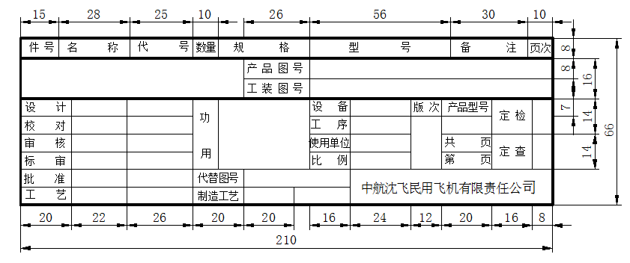

附录E Appendix E
(规范性附录) Normative Appendix
B777、B787工艺装备图样标题栏Specified title blocks style for B777 and B787

E.1 总图图样标题栏Specified title blocks style

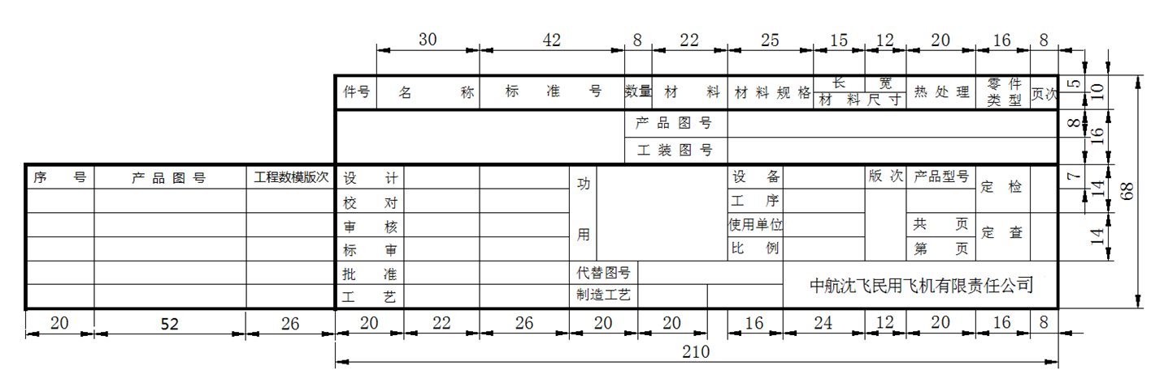
注：对于左右侧完全对称的工装图纸，右侧工装的授权数据集应与左侧一致。
NOTE: For the tooling drawings that are completely symmetrical on the left and right sides, the authorization data set of the right tooling should be consistent with the left.

